# Steps to create twitter app and generate access credentials.

Click on <https://dev.twitter.com> and click on “My apps”



Sign-in using Twitter Id and Password

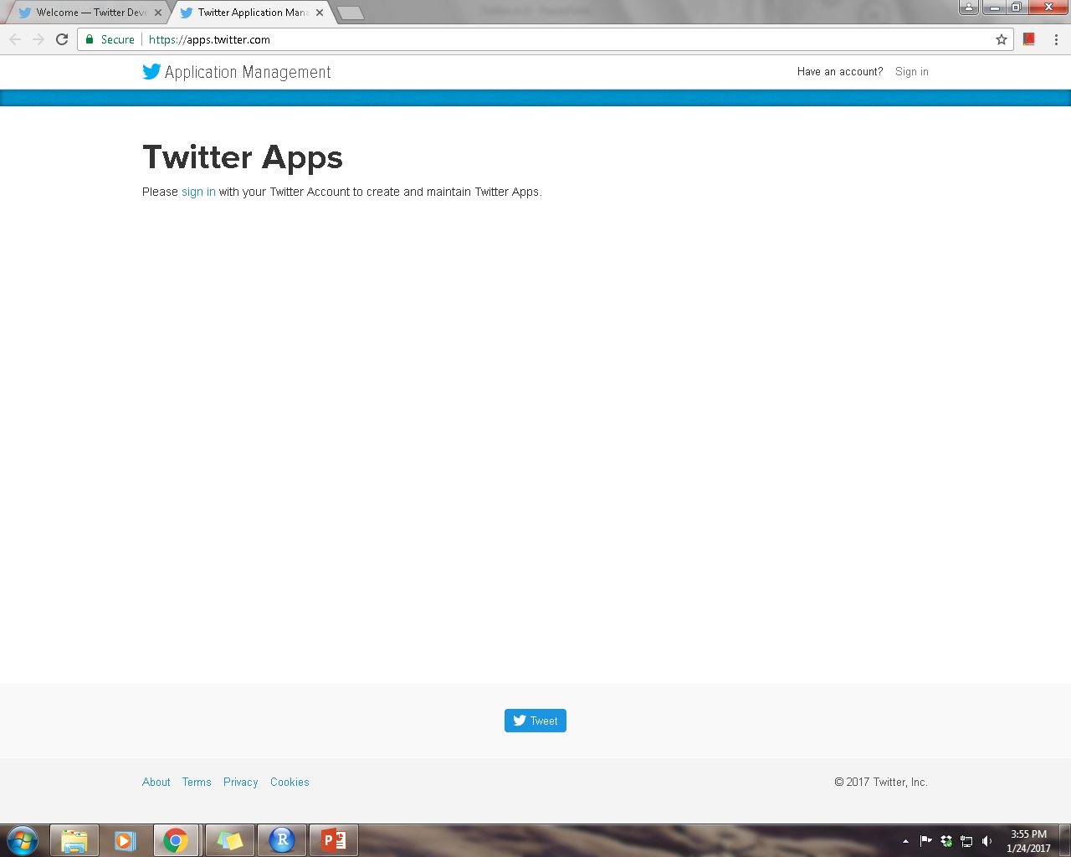

Click on “Create New App”

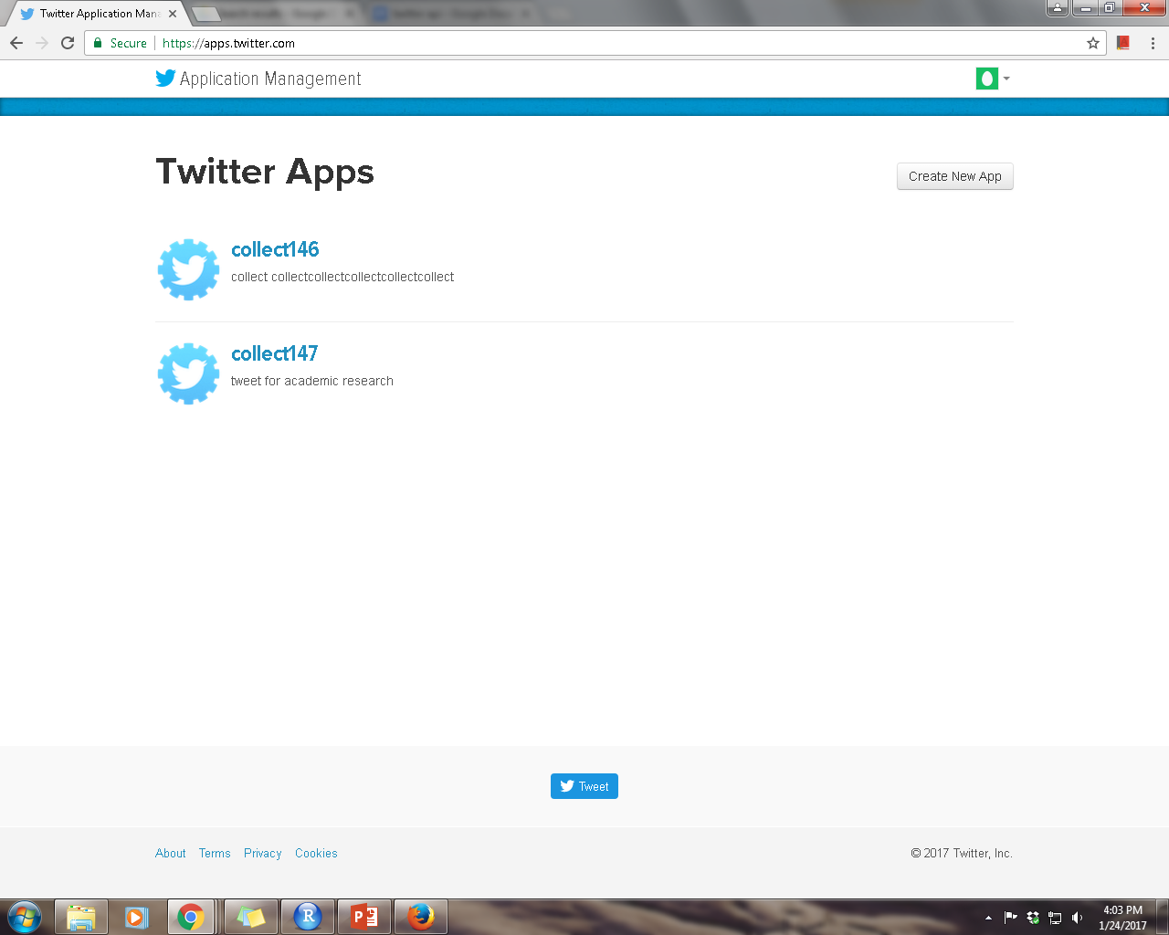

Complete the new application form as shown below.

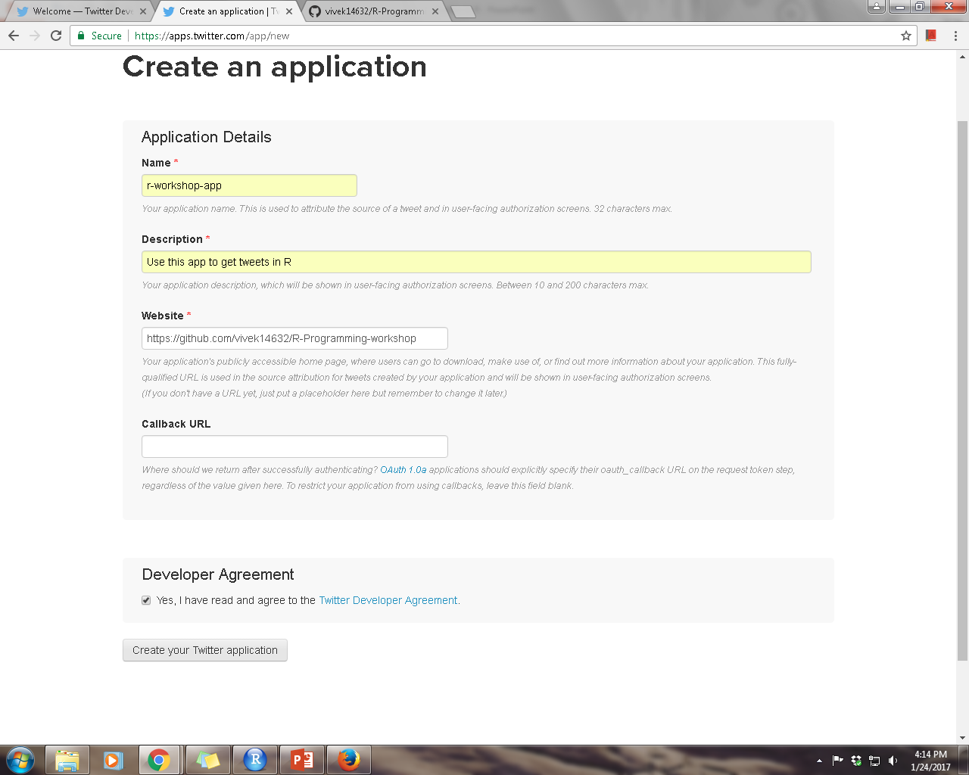

Select the “Developer Agreement” and click on “Create your Twitter application”

Click on “Keys and Access Tokens” as shown below.

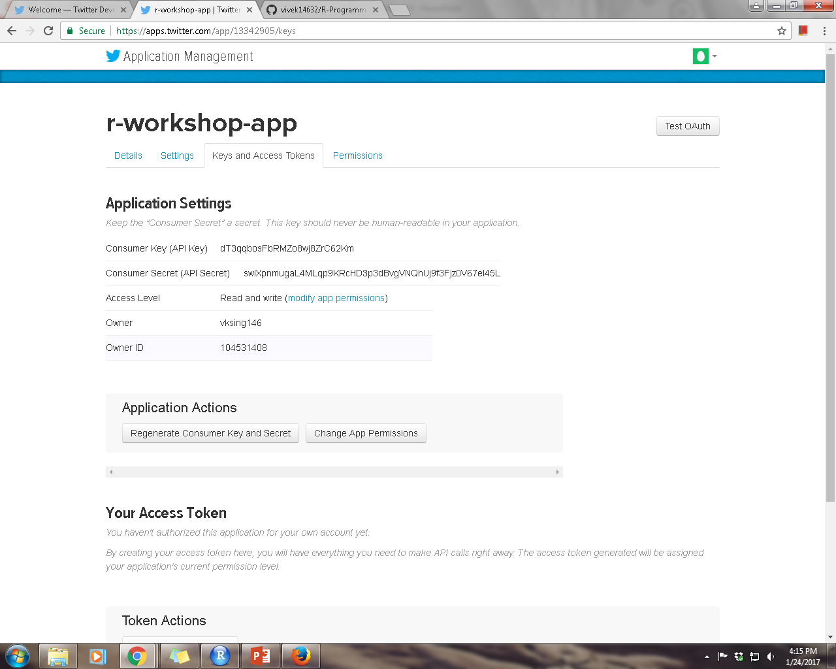

Please copy app “Consumer Key” and “Consumer Secret”

Click on “Create my access token” shown in the page below to generate access tokens.

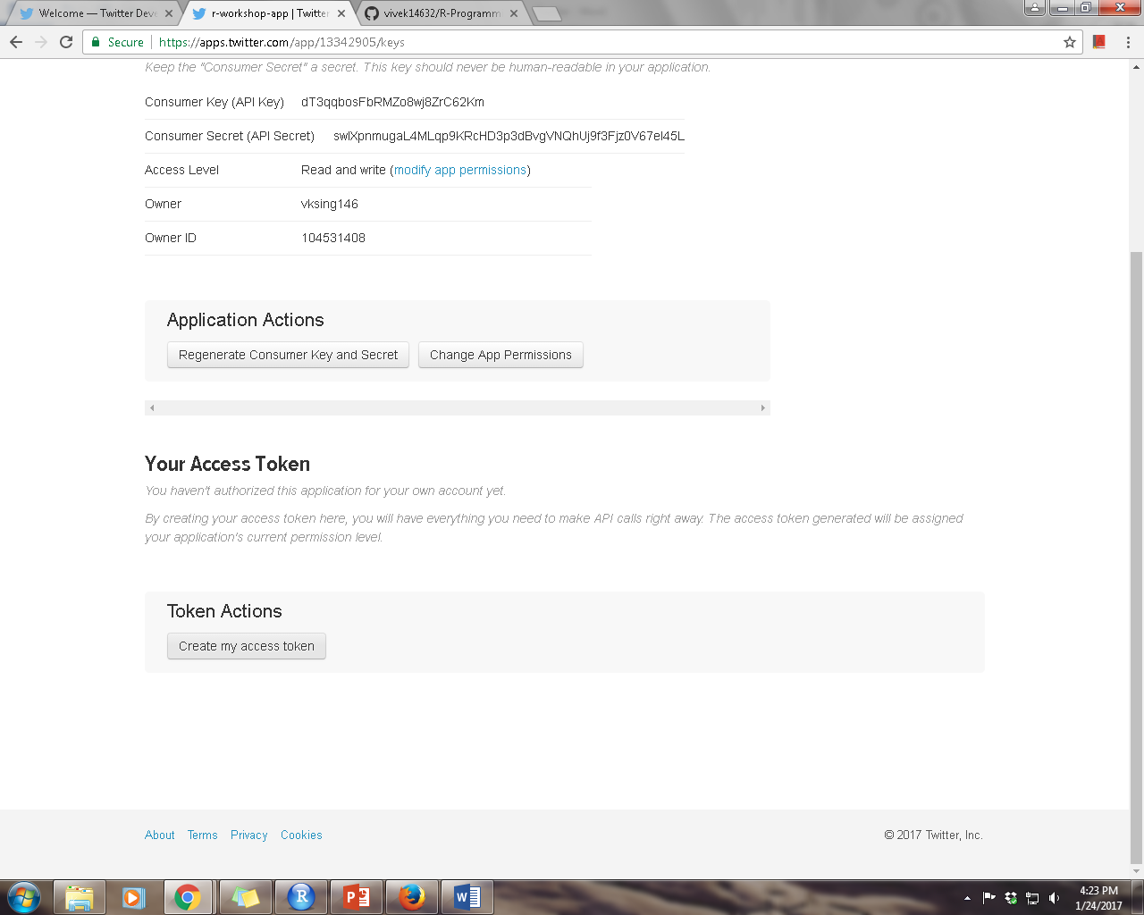

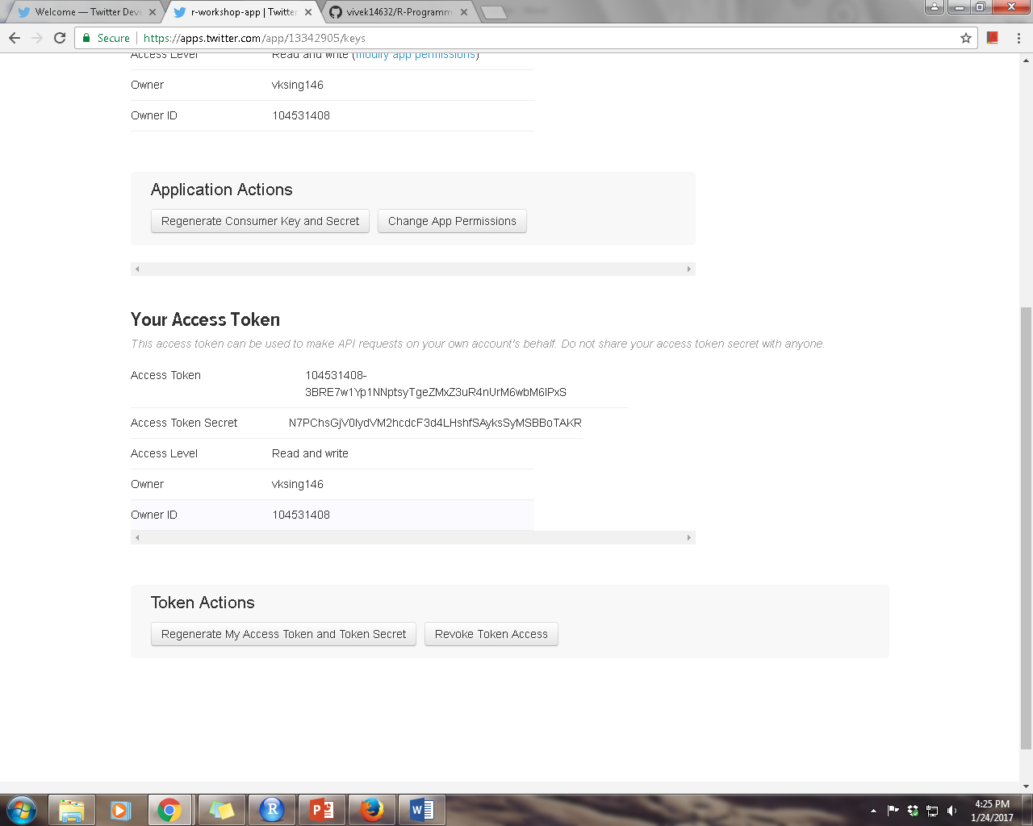

Copy your “Access Token” and “Access Token Secret”